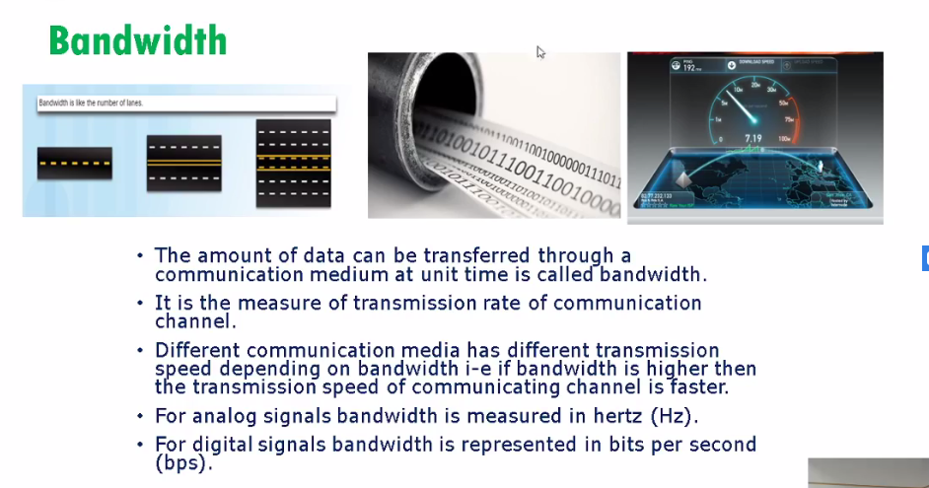

Maxnimun ktna data jasktaa h

Bandwidth or speed m kia farq h ? bandwidth maxi h or speed mtlb ktna data trafner horha h jse 2mp ka connection h toh apko lage k speed km h toh speed zyada krwalein

Speed:ktma actual transfer horhaa h

Bandwidth:maxi capacity kia h

Eg bd is 100mbps kit oh kbhi bhi 100 pora nh travel krra hota h qk bht se or links bhi hotey h

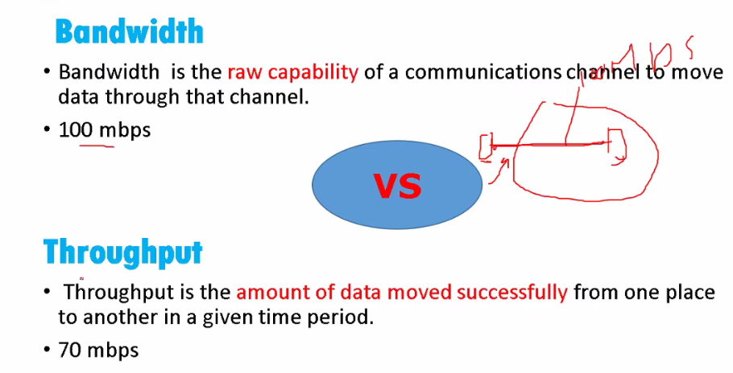

Jse car m speedometer hota h toh wo bandwidth h max limit lkn asaal m hum use max tk kbhi le ja nh skteey h ..

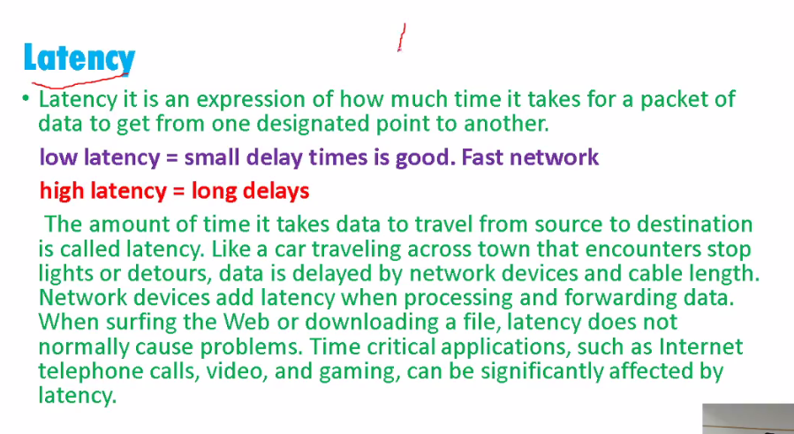

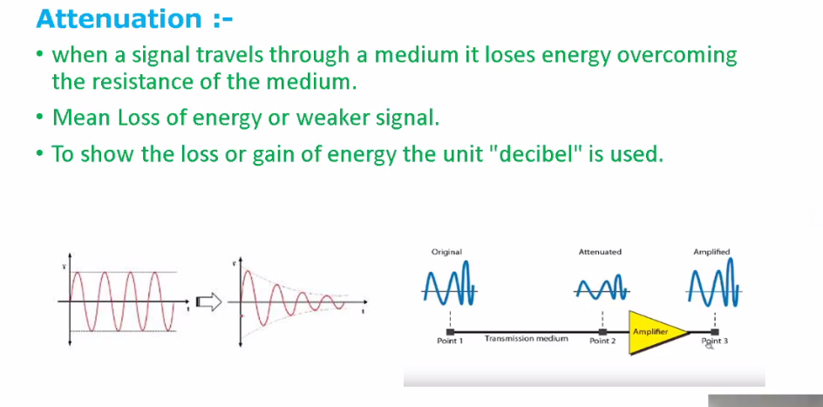

Jis point pe signal week hojatey h wo attenutation h ek limit hoti h jse wifi ki range us range k bd signal week hojati h toh wo attenutation h phir amplifier genereator repeattator wagera use krne partey h

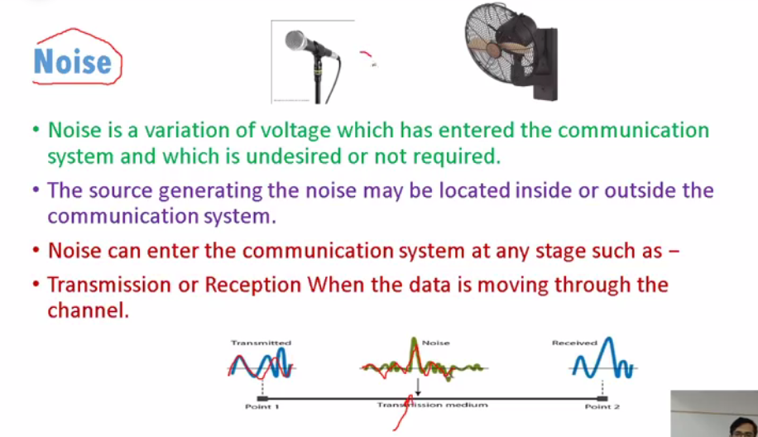

Noise ki waaja se distortion create hojati h

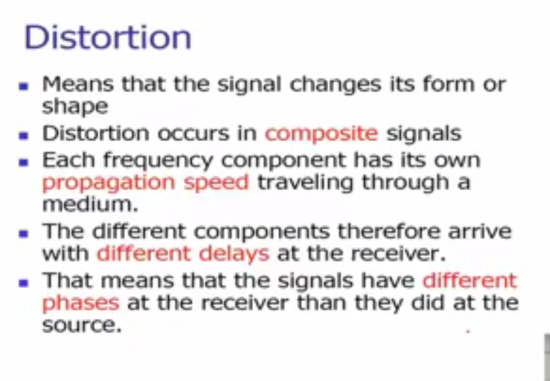

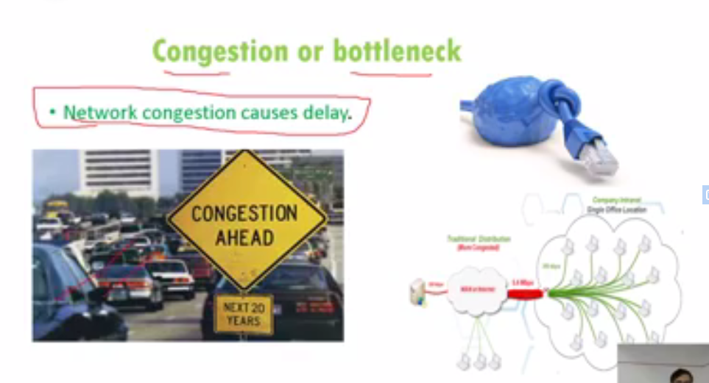

Network design or design model

2 types

1)client-server

2)peer to peer

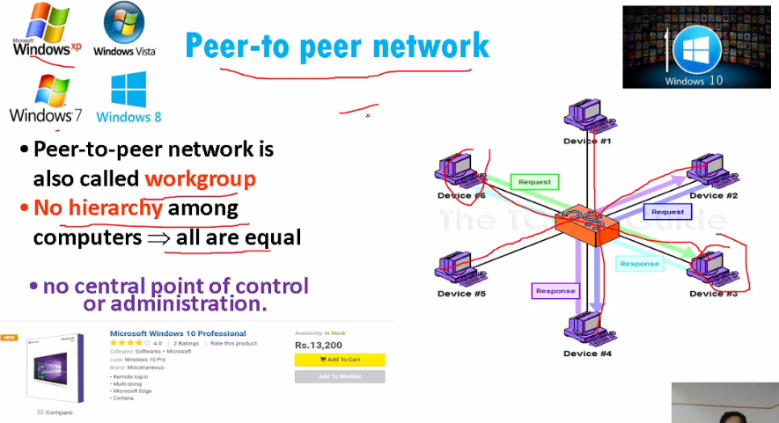

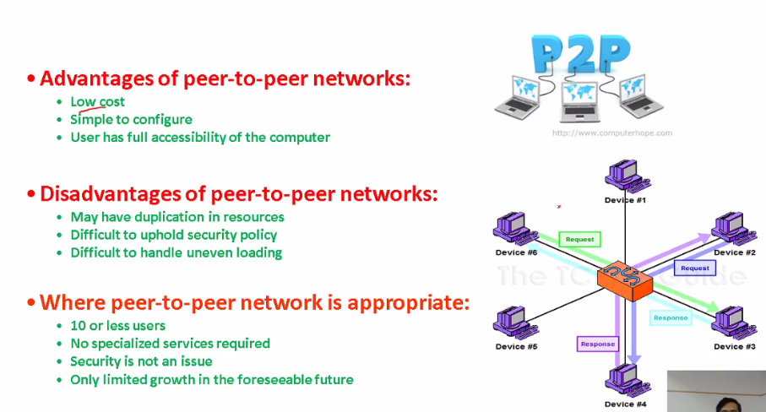

Advantage:

1)Extra koi chz purchase nh krne parti

2)-youtube ki video dkh kr bhi configure kr sktey h.

3)-ap k right accessible hotey h sare user k lye .

Disadvantage:

1)Duplications bht zyada hoti h

2)-secuuirty policies bht muskil h qk har pc k pass apne resources hotey h

3-backup indivisual lena parta h

Uses:

10 or less users

Client –Server:

Ek os chlrha hota specialized hot ah baki sare comp is server k resources use krtey h

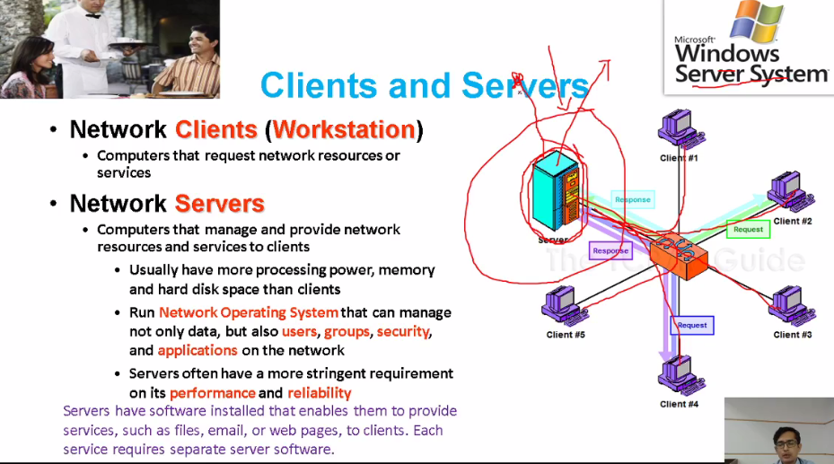

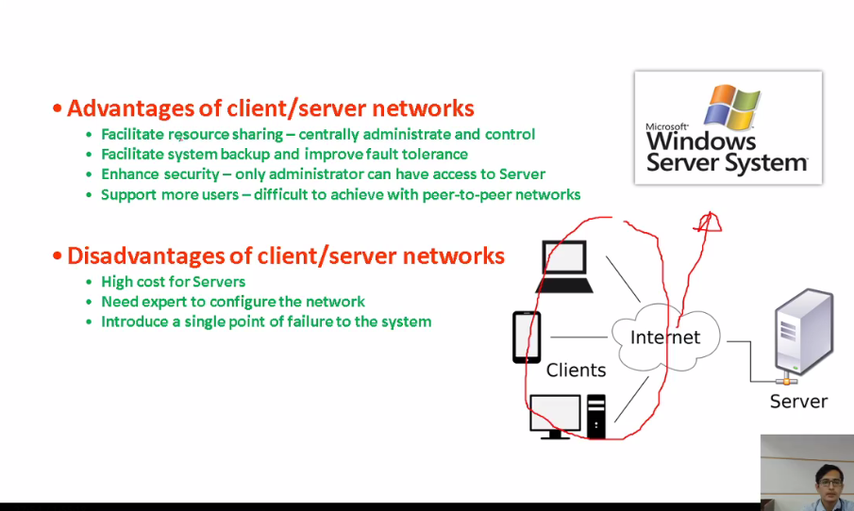

Area Networks:

Network ko areas m divide kia h

1)LAN--🡪Local area network

2)WAN🡪Wide area network

Most classified

1)PAN🡪Personal area network eg hostspot

Limited time k lye create hota h

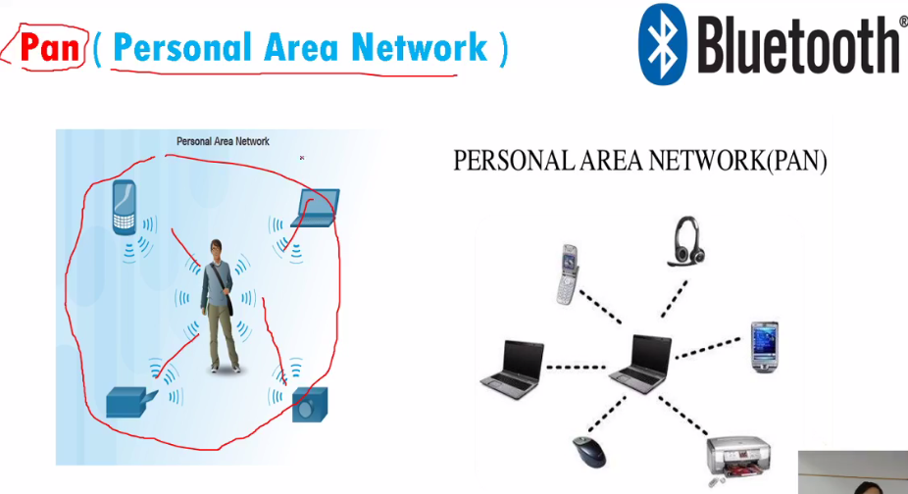

LAN:within a building or office

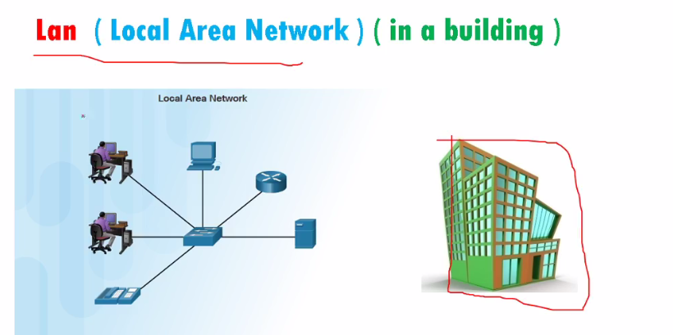

MAN:

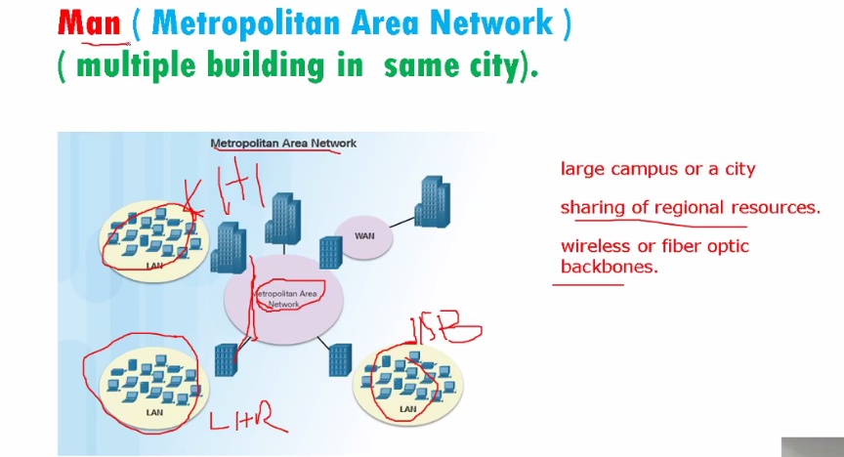

CAN:(universirties )

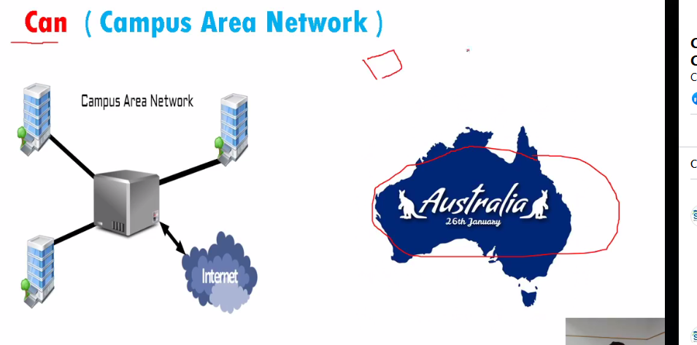

Wireless LAN:

Bht se aise jaagh hoti h jahan pys infrastructure nh banwa sktey toh wireless controller k thorugh

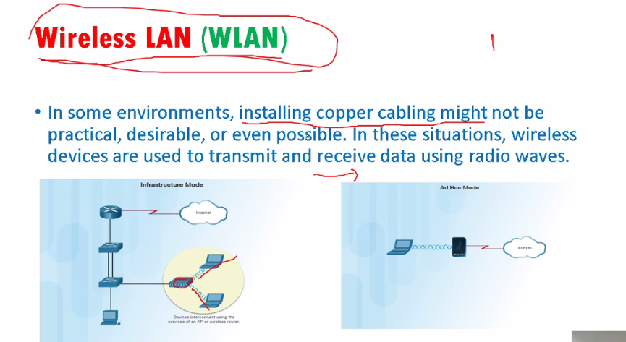

SAN(Storage area network)

Normally use in data centers

Data ki reachbikity bht fast chahye hoti h

Devices:

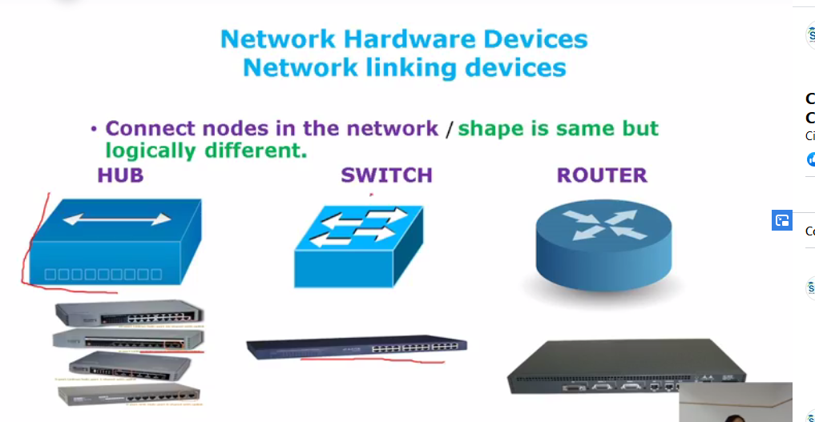

Hub:works on half duplex.pc a 1 pe h pc c 3 e .pc ka mode full duplex h woe k signal bhjta h hub ko toh hub half duplex h wo reply krega toh px khud apne app ko half duplex krleta h toh protocol csma/cd Carrier sense mutple access /collision detection activte hojata h..

PC idle condition dkhta h afgr wo free h toh send krega hub bydefault broadcast krta h.

1-ios nh hota(cisco k os ko ios boltey)

2-half duplex

3-broadcast the data

Switch:port ko monitor krrha hota h or un k behalf pe mac address table banata h

Router:

Data send krne k lye we need dest address two types of address we have

1-IP address.

2-MAC address.:physical address of device.pc intailly comm k lye nh tha jab comm k lye fun add kre toh we add NIC nic pe ek mac address hota h yeh fix h smjho k yeh ghr ka address

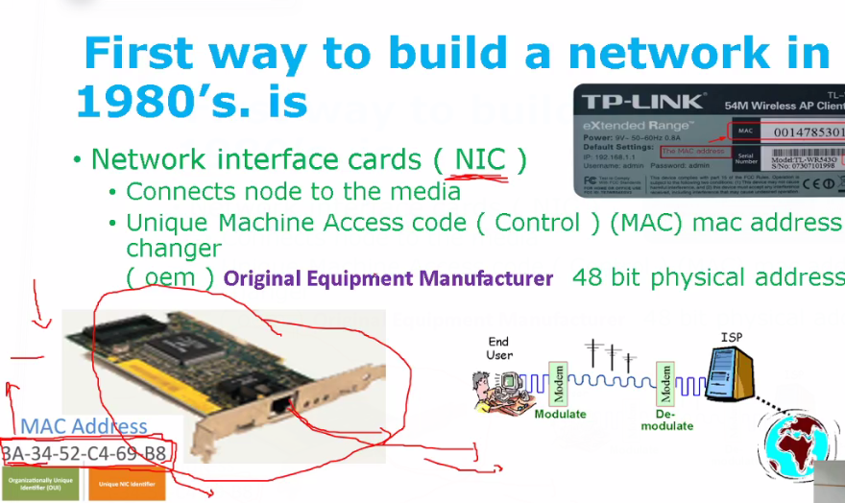

3-Port address

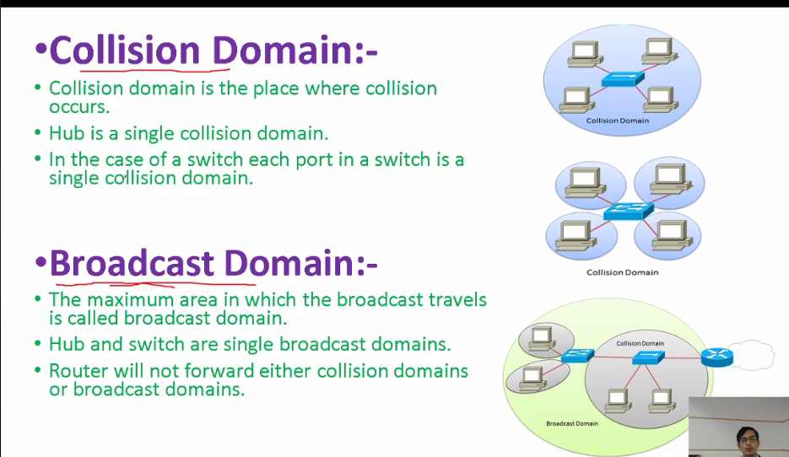

Collision:jab 2 pc ya port sab ek sth send kre data

Hub m single media connect hota h ab chahye ek hub k st 10000 pc bhi ho toh wo signle colssion domain h 🡪Hub single broadcast and signle collision domain h

Switch:16ports means 16 collison

Switch per port collision domain h

Switch single broadcast domain

Switch m collision hota kahan h agar dport sport alaag alaag h ..

Switch full duplex pe km krrha h coliison port o device k beach m hoskta h hoskta h device khud half duplex pe km krrhe ho toh nic khud single duplex ban jayegaaa

Router broadcast domain ko off krdeta h

1-pkt:

3rd class

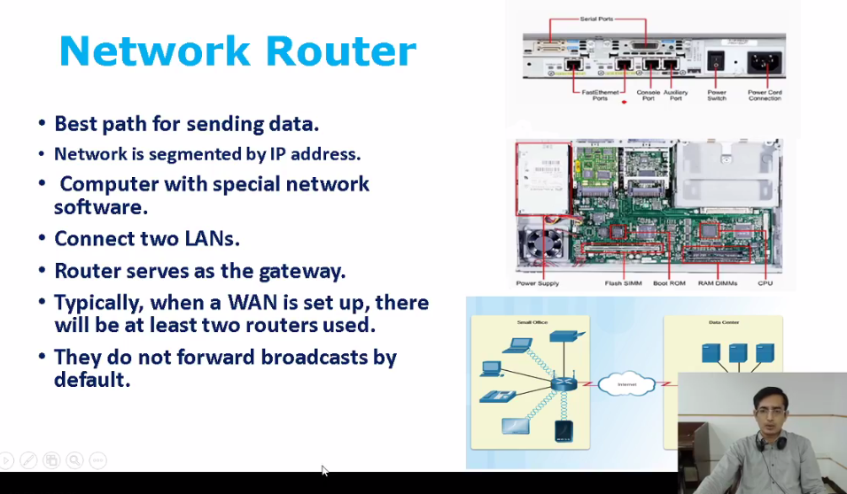

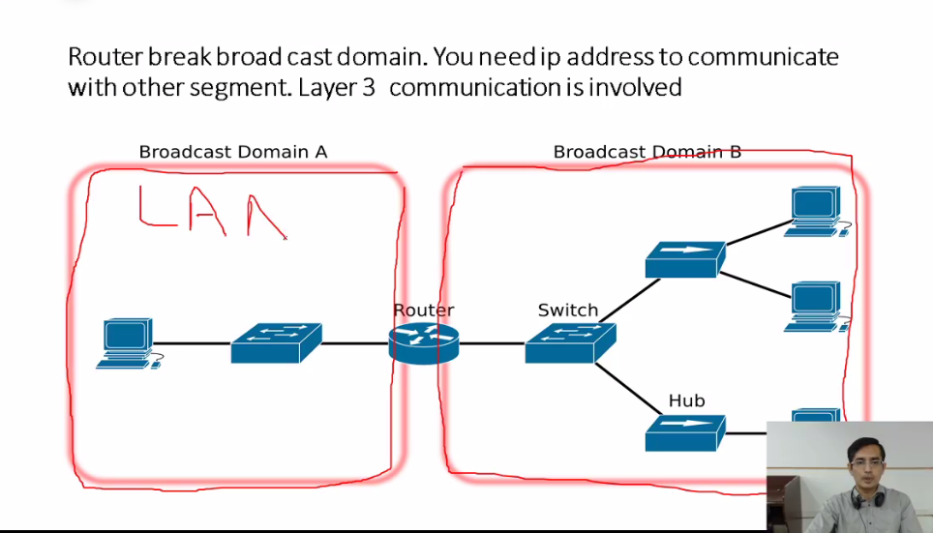

2 ya 2 se ziyada net k comm k lye router chahye hota h

Different broadcast domain ya dosre n/w ko connect krta h

Best Path for sending the data

Mutiples router lage hue they h toh best path nikl kr send krta h data.

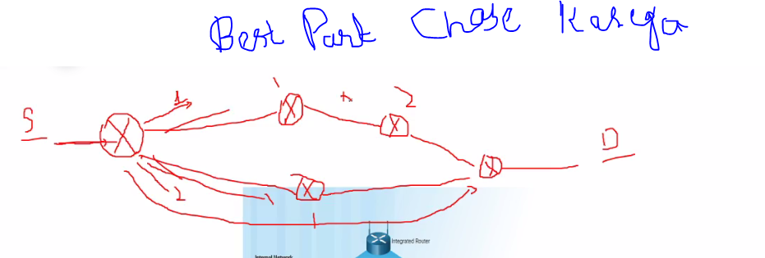

***Network Topology***

n/w k phy ya logical arrangement

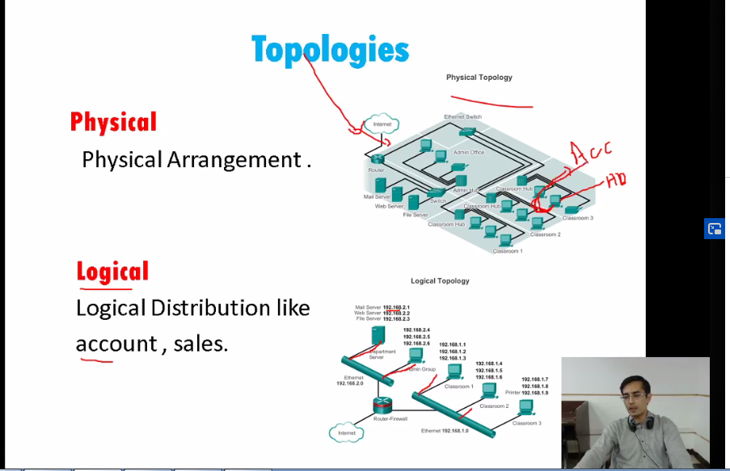

Logical mean rkhe corridor h par wo connect h HR dept wagera se

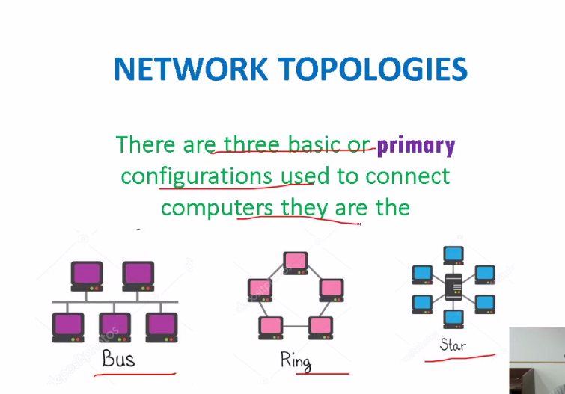

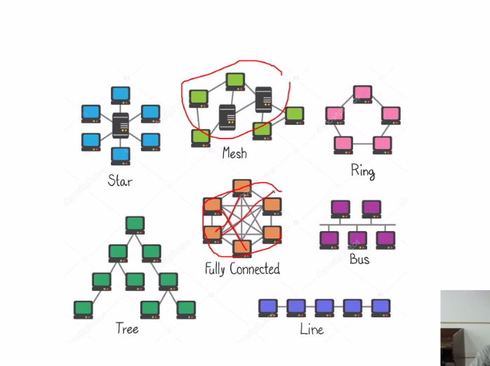

Most common is star.

90’s m use hoti cable RG58 RG59 standard thi bus k lye ajkar TV k cable wagera m use hoti h

Is

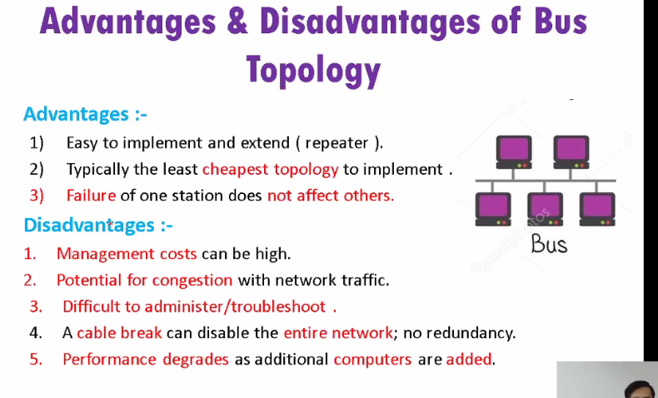

Ring:ek token k thorugh comm hoti thi jis ko comm krne hoti thi wo tocken leta tha or use send krdeta tha .

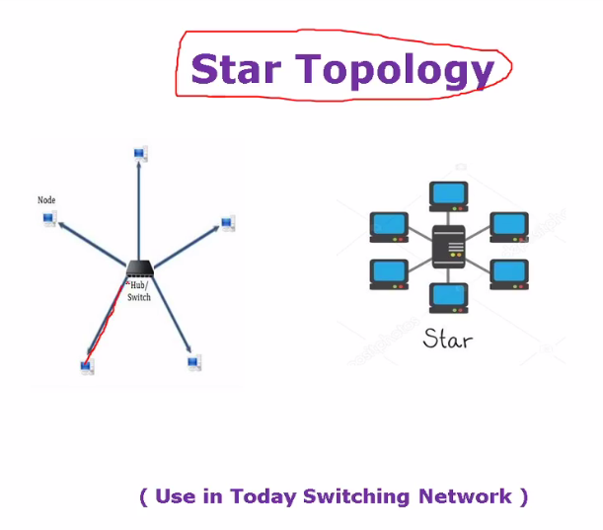

Switch star pe km krrha hota h

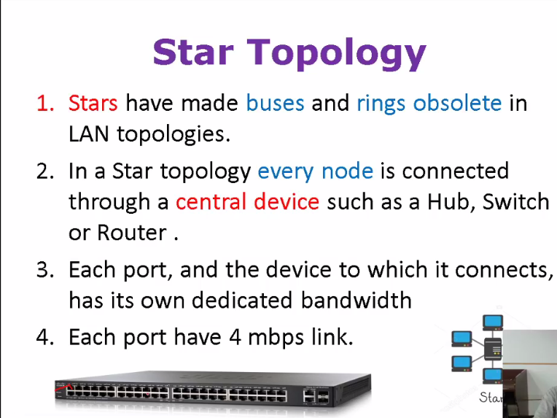

**Mostly IPS most krtey h**

**Types of WANS:**

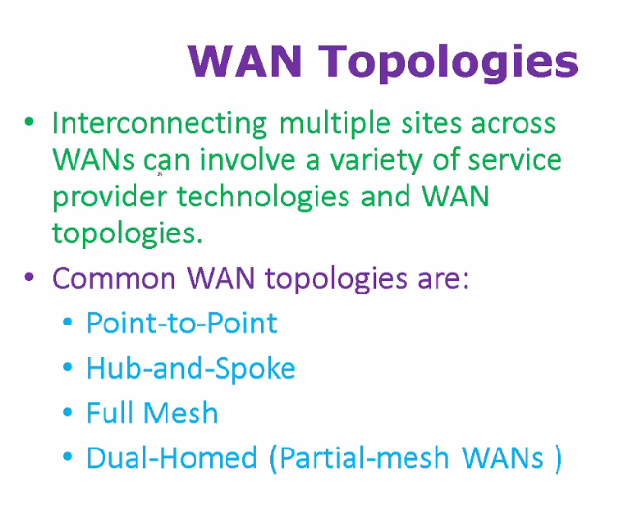

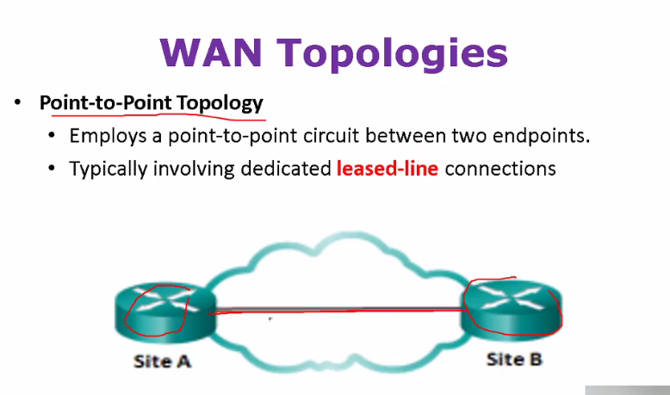

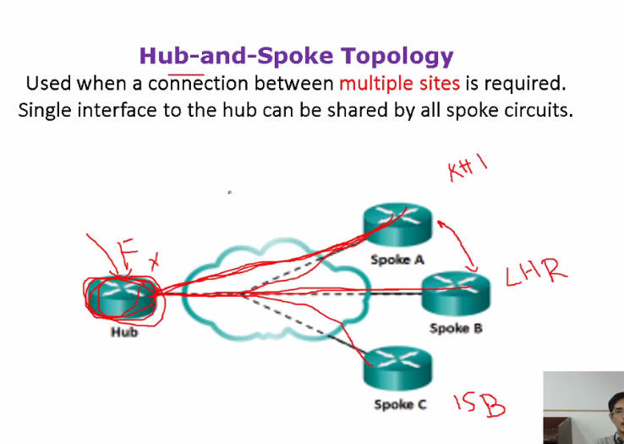

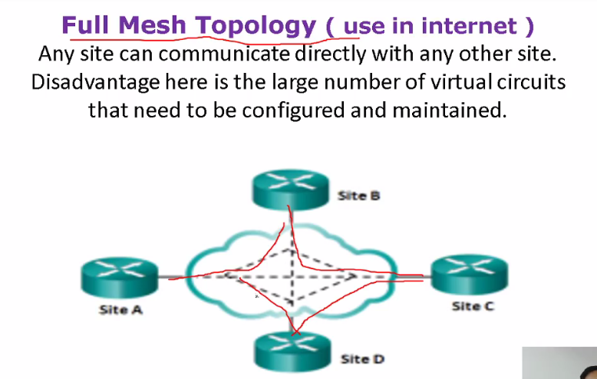

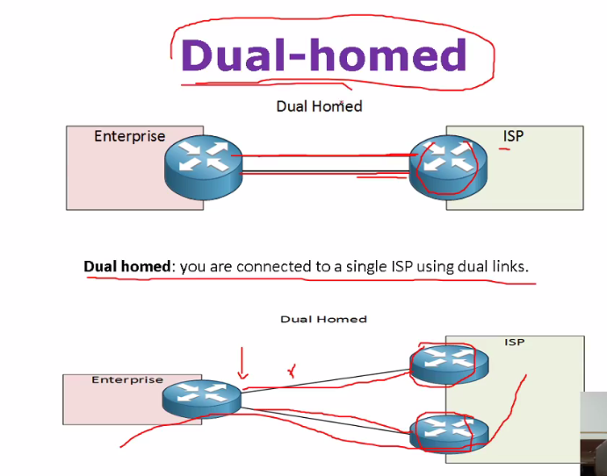

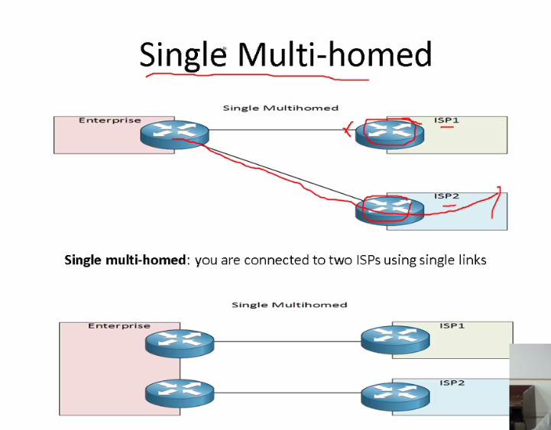

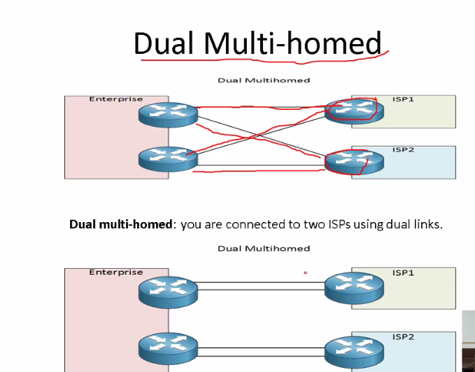

**Guided and Ungudied Media**

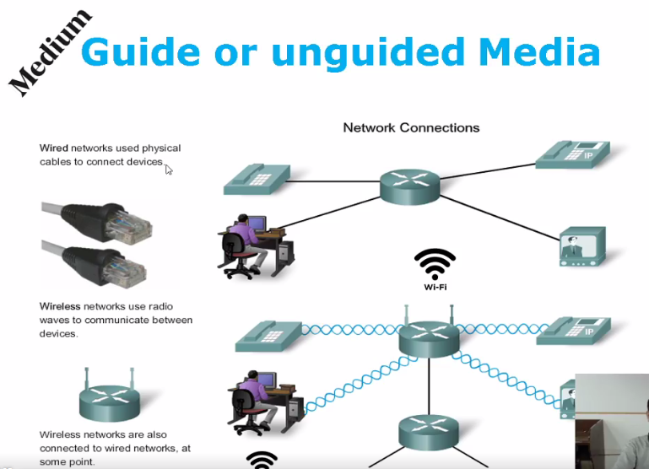

**Guided:Copper and**

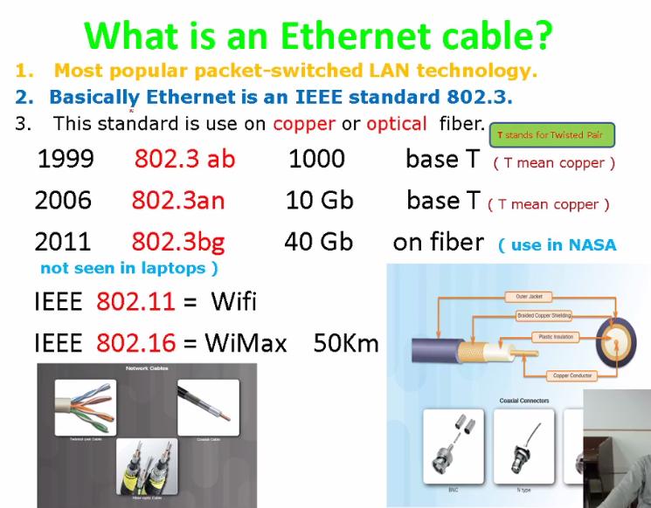

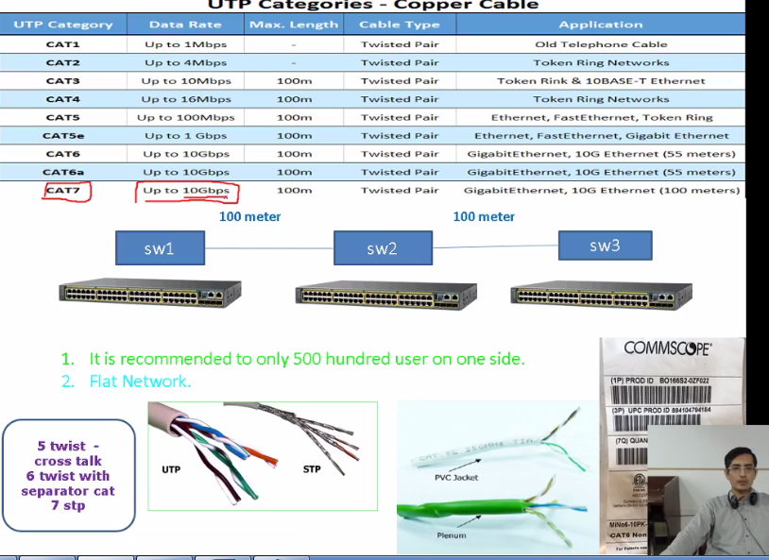

**In sab m jo coomin h wo 100m h mtlb max 100m tkdata sahi carry kregy us k bd attemutation ajayega or swtitch lagana parega**

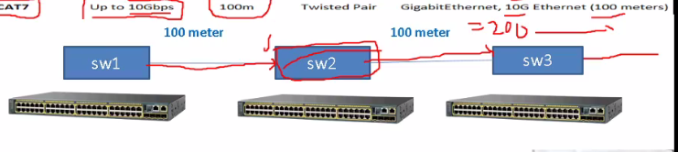

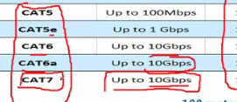

**Yeh sare normally use horhe hoti h n/w upeer wale telephone wagera m use hti h**

**Best Conductors:**

**Gold->copper->alum->iron**

**Manufacturer copper k sth alum ya iron wgera bhi mix kr k detey h islye throughput km hojataa h aksarr..**

**Cable letey wqt check krle ap k apka km ktna h jtna jse 10GB wagera**

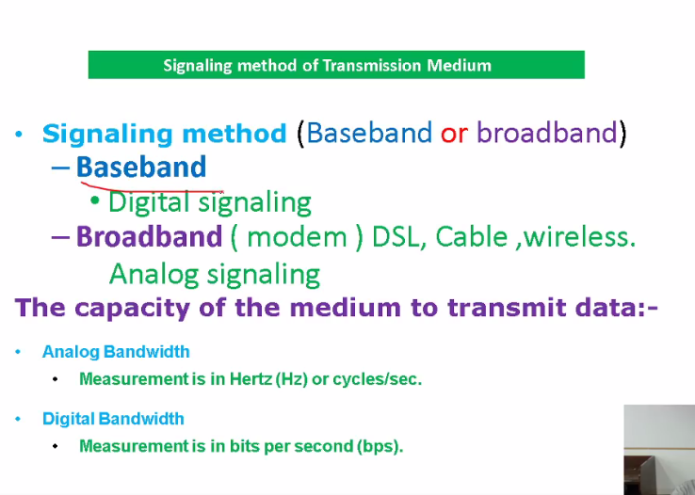

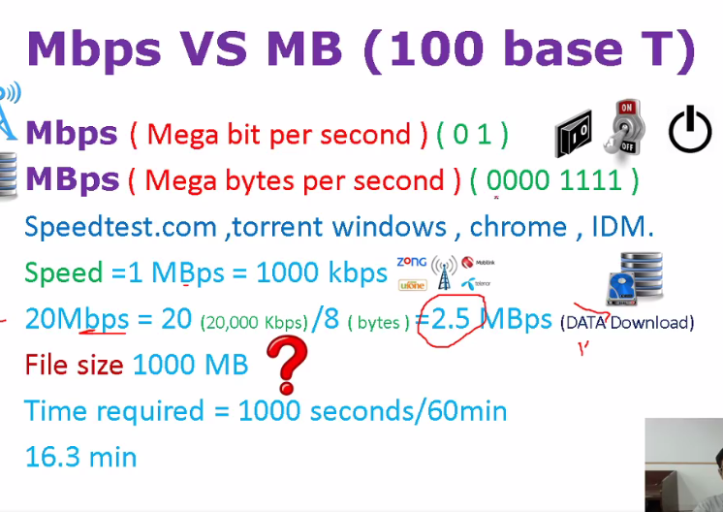

**2 standars h T-568A and B bas farq color ka hota h**

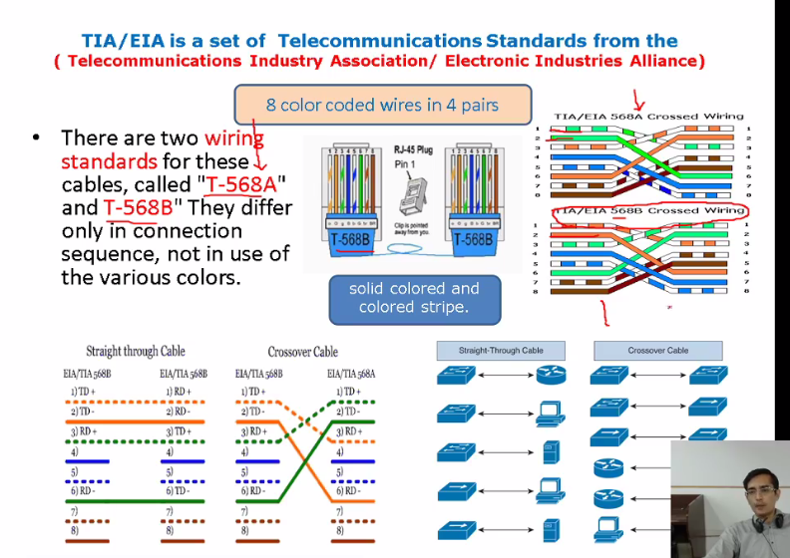

**Straingh Through Cable:diff diff device k lye**

**Cross Over:Same devices k lye**

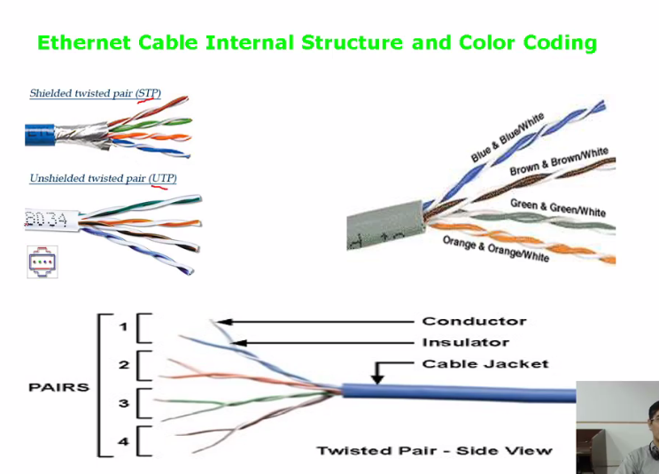

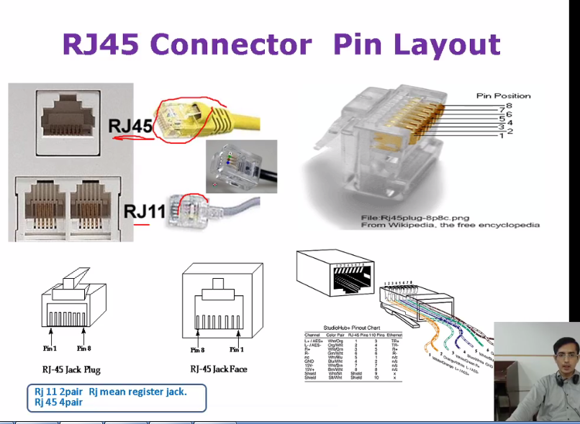

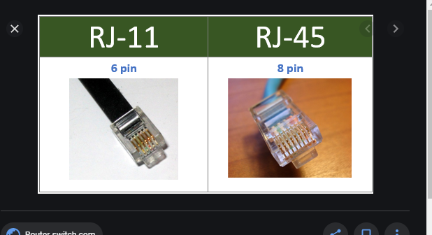

**Opical Fiber**

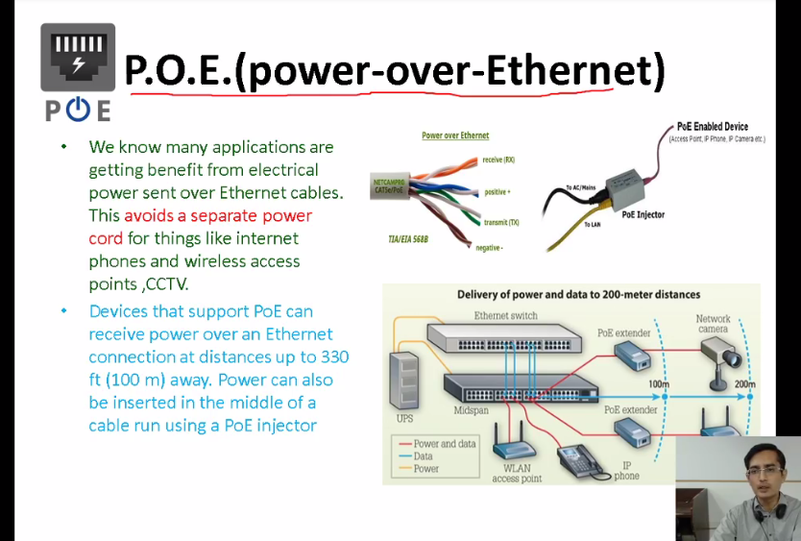

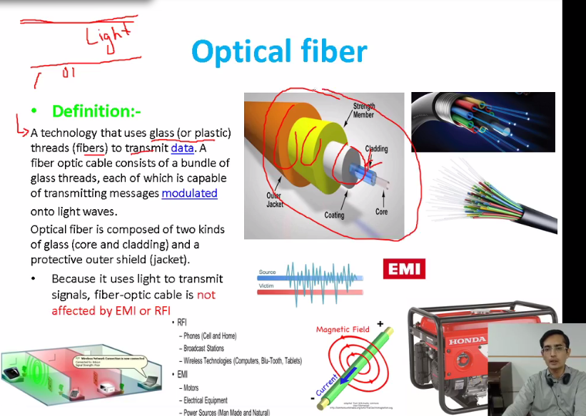

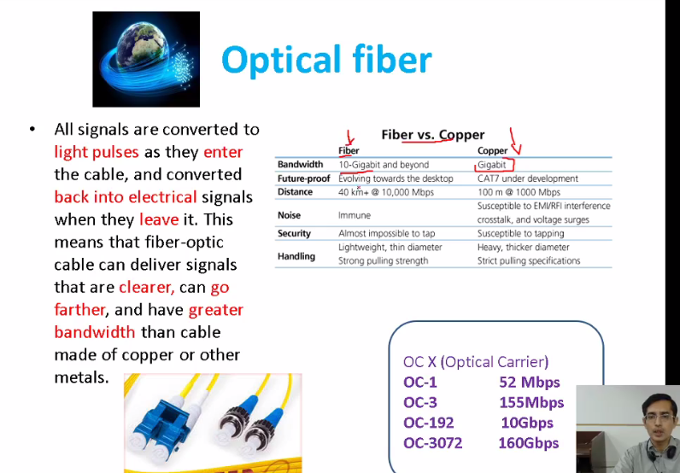

**Class – 04**

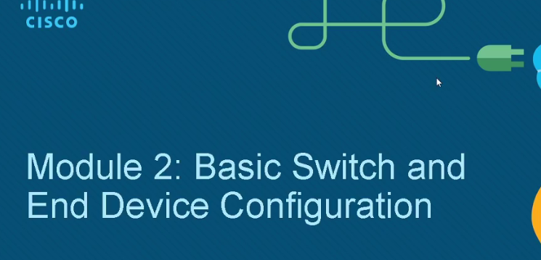

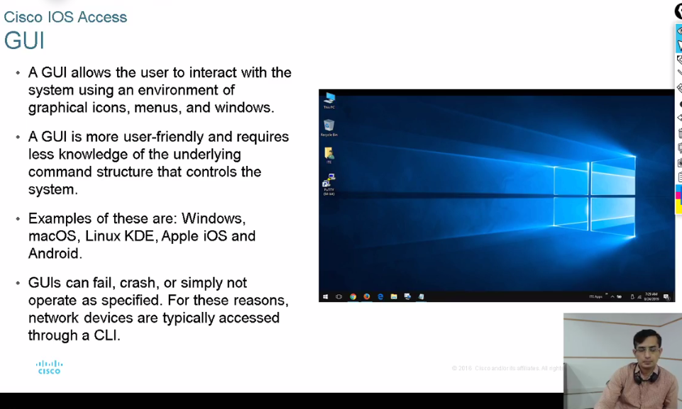

**Os m 2 chz h gui or cmd line ..**

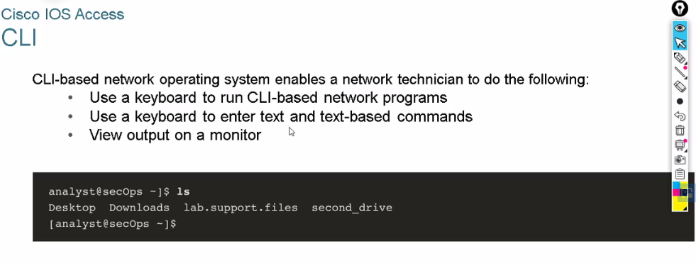

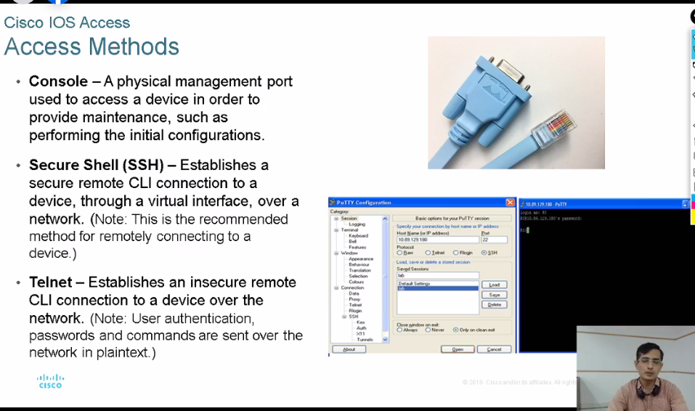

**Kse device ka access ks tareeke se lein**

**1-physical:console cable se device ko connect krletey**

**2-remote**

**Remote Access:**

**2 proctols use hotey h 1)ssh:yahi secure h means encrupted**

**2)telnet comm plain text m hoti h**

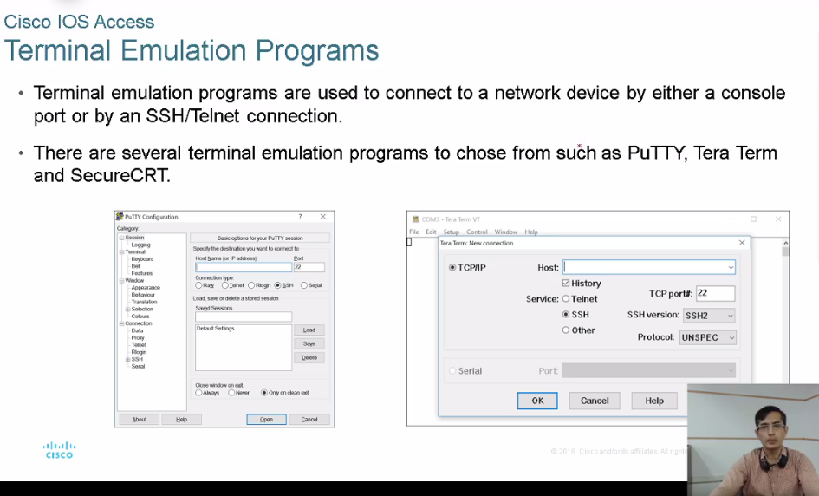

**Putty tera term wagera h yeh khd pochta h k ssh telnet kia use krna h**

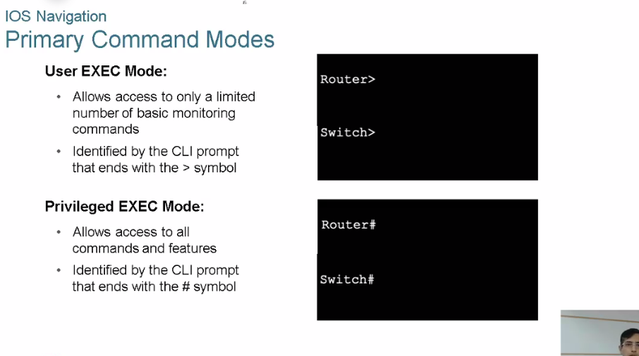

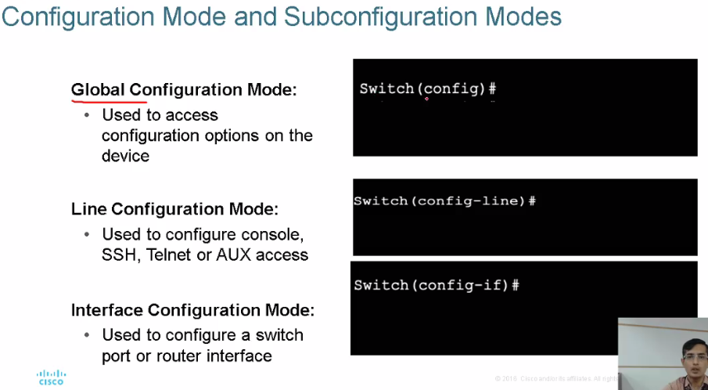

**Ios m 3 tarha k command hote h**

**1-User mode : >**

**2-privilege: #**

**3-global:**

**Why we need diff diff mode?**

**Actually jab kse company m km krtey h toh team hoti h team m sernior junior troubleshoot k ye wagera ise rights hoteey h ..toh ise tarha se role k lihaz se command di jati h**

**Jse exex mode normally desktop engineer k lye hoteey h**

**Privileged exec : k pass rights hotey h**

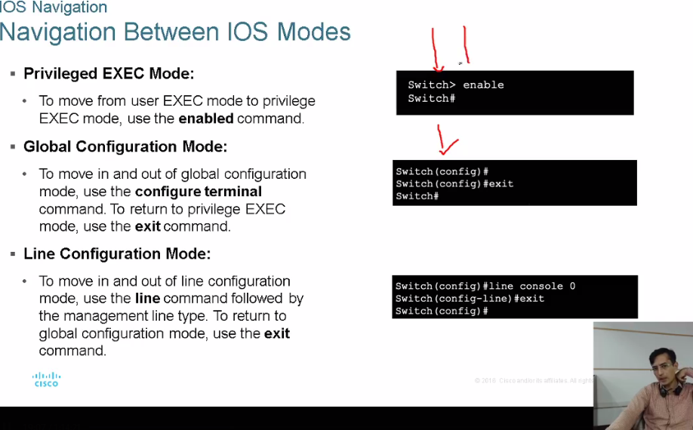

**Console cable blue color ki device ko access krne k lye use hoti h**

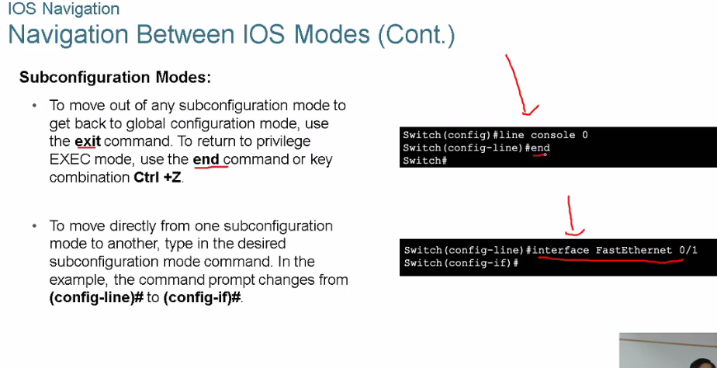

**TOPO:**

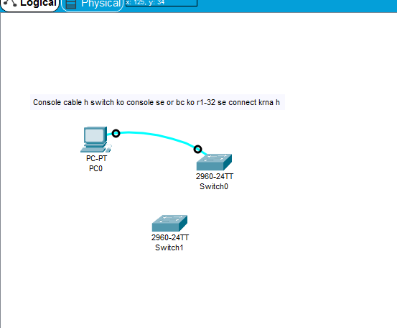

**The Command Structure:**

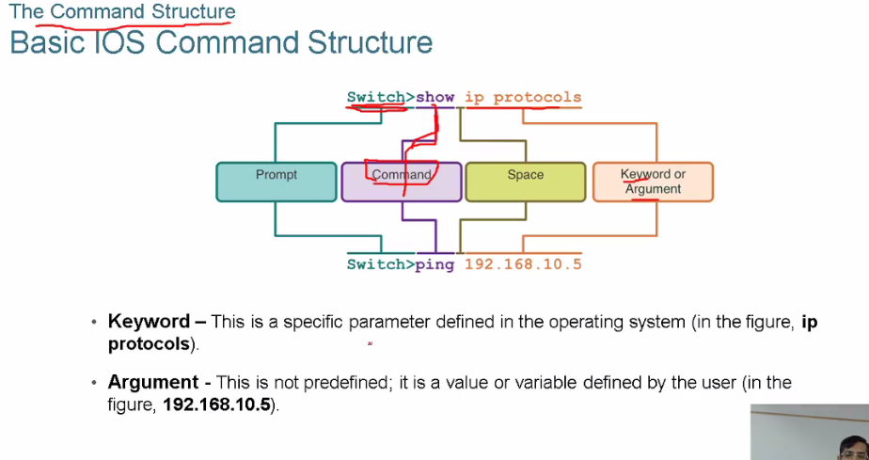

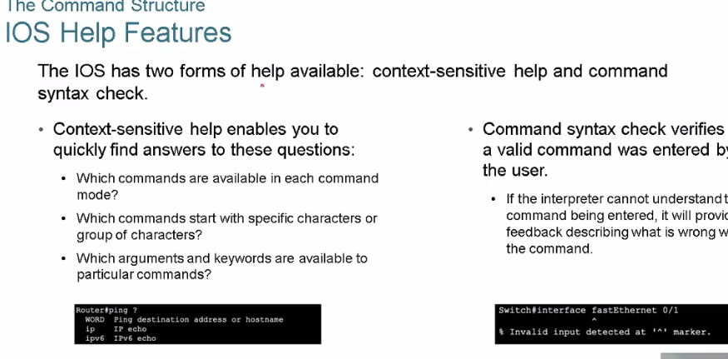

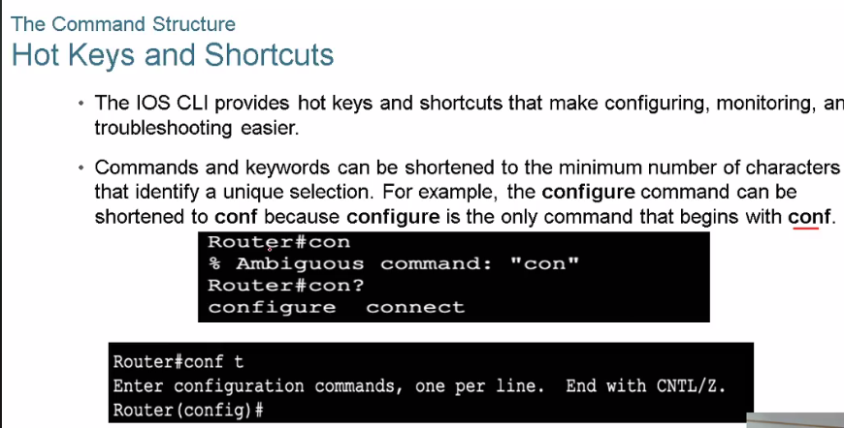

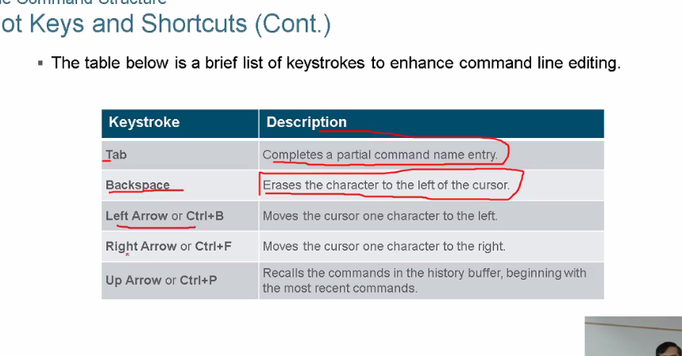

**Basic Device Configuration:**

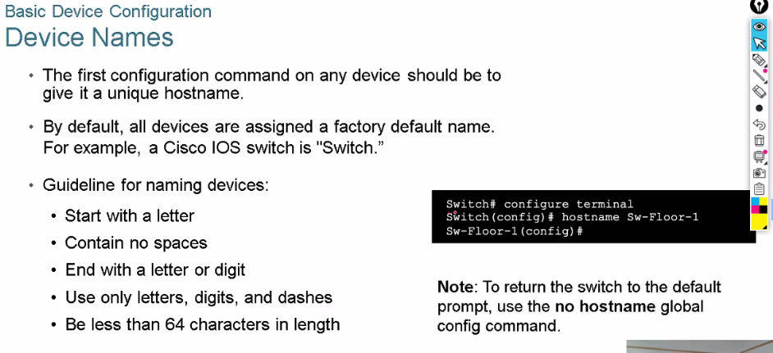

**Initial configuration of switch**

**To change name of switch:# hostname DeviceName**



**To Change password of switch**

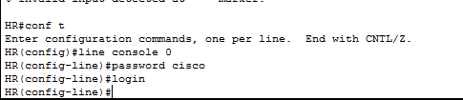

**Login lkhna zarori h wrna wo password set nh hoga**

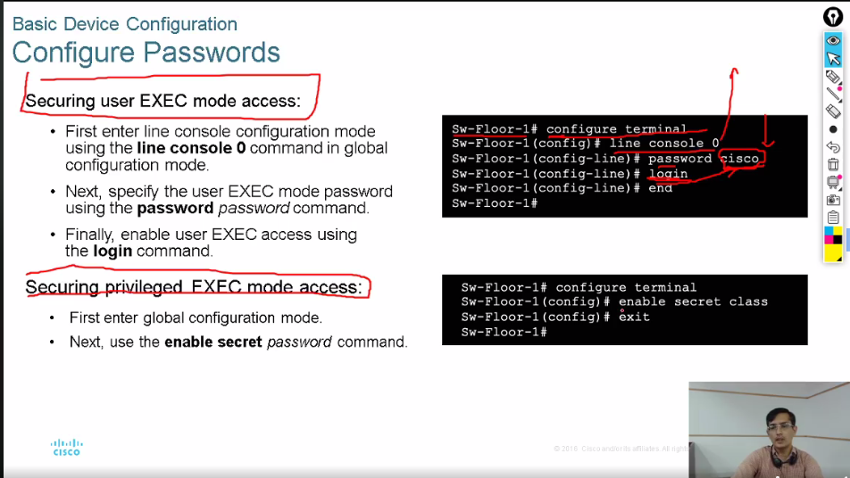

**Prevliges or monitor pe dono pea alag alg password dia jataa h**

**Conf k lye enable secret password lkhdo**

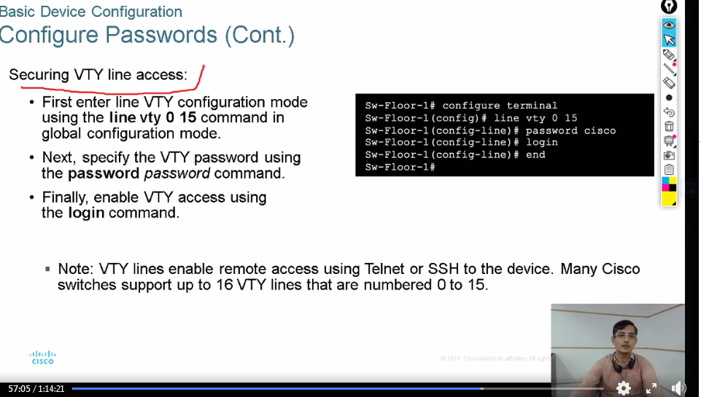

**Ab tk user access then prevlileges mode ko secure krlia h ab hume remotely access krne k lye secure krna paregaaa**

**Line vty 0 15 mtlb 16 secure hogaye agar 4 krne h toh**

**Line vty 0 4**

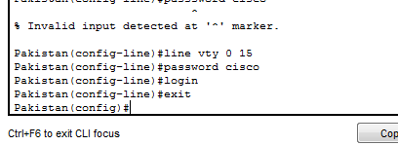

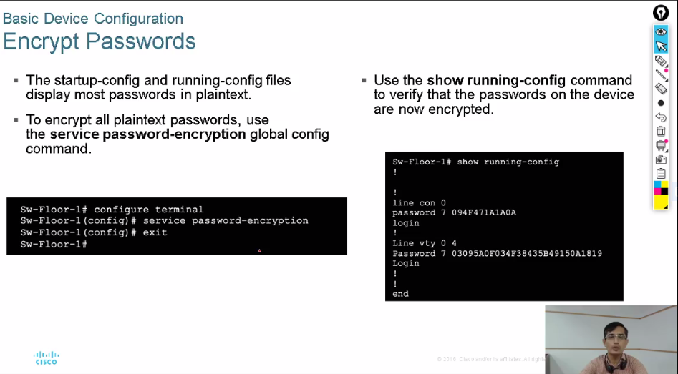

**Hum apne password ko encruption bhi apply krsktey h**

**2 tarha ki conf hoti h ek startup-config and running config file**

**Device m 2 config hotey h**

**1-runnig config**

**2-startup-config m save krne hotey h ta k permanently save rahe (N-V Rom)**

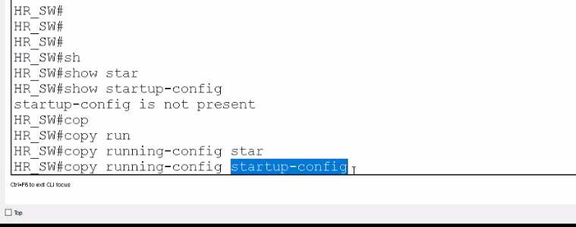

**Ise running config ko startup config m change krrhe h**

**Sara km krne k bd startup-config m save krna is zarori wrna agey bar won h legySare password encrypt krne h toh use**

**Service password-encryption**

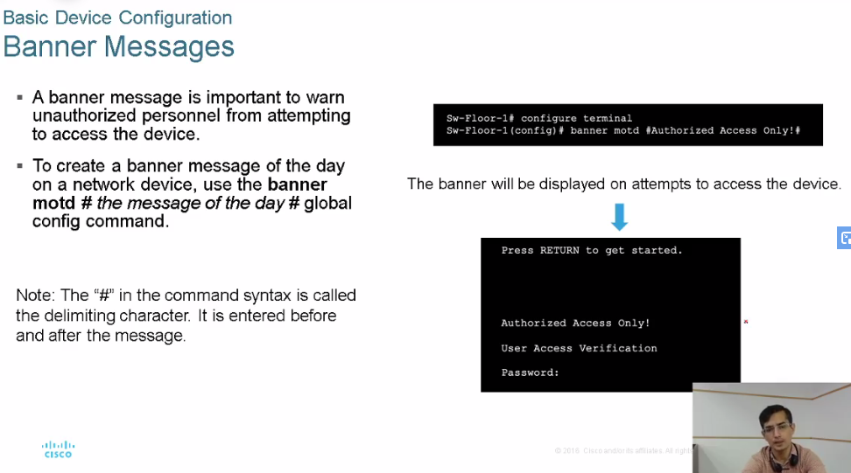

**If you want to change banner go in config motd “Message of the day”**

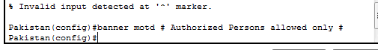

**Config->#banner motd # Message #**

**# shuru or end m lagaaya h k device ko pata chl jaye k starting ispe hue h toh endingbhi ise pe hogi like terminator type zarori nh k # hi de we can gave any of the character**

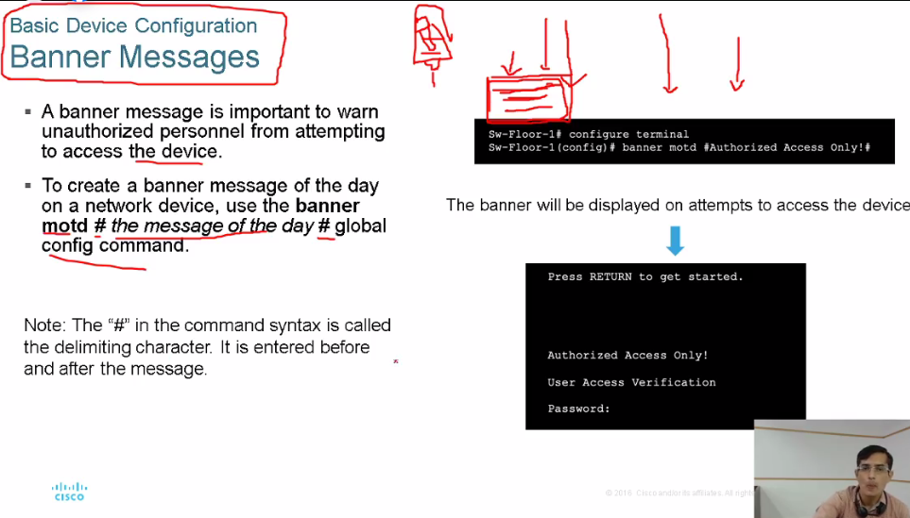

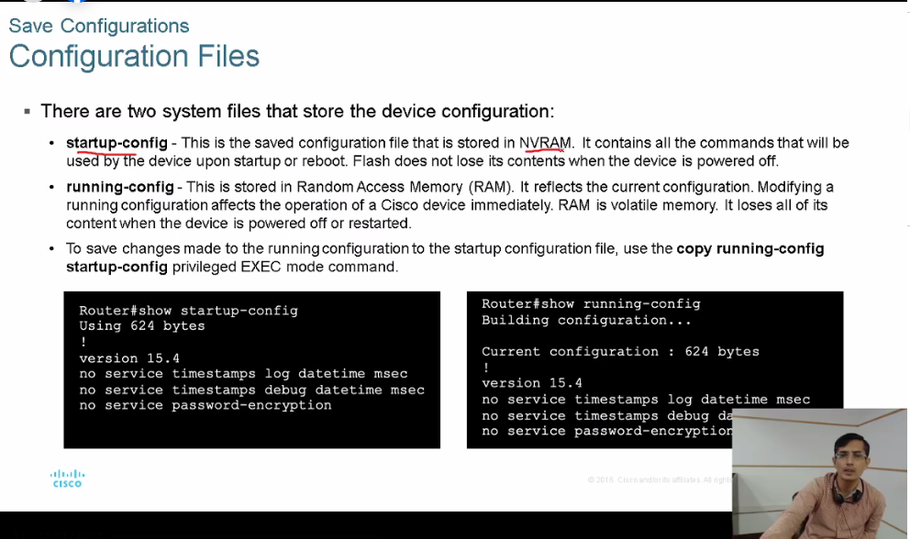

**Reload restart krtey h device ko or ap offline hojatey h users k lye n.w unavaible hojayegaa**

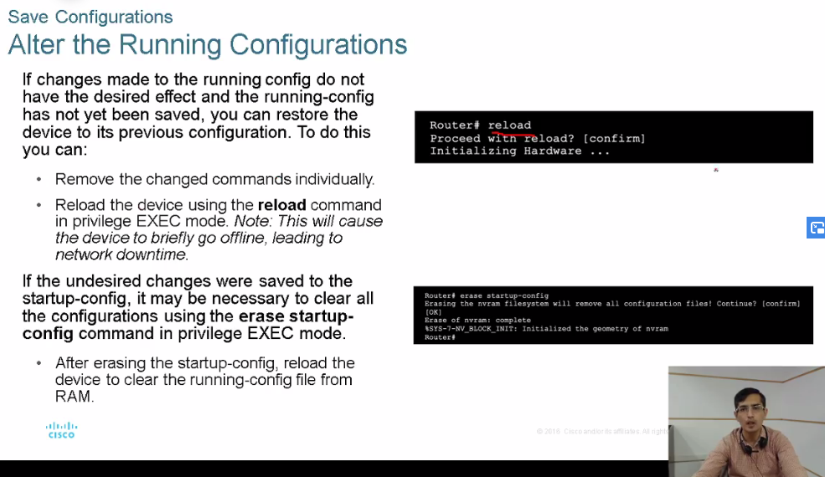

**Port And Address**

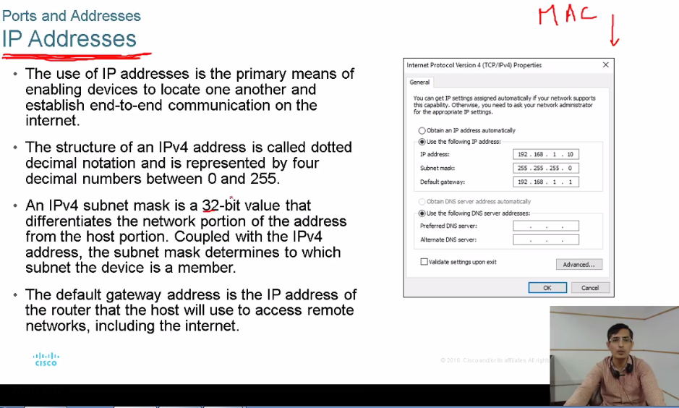

Ipv6 ko we represent in hexadecimal ..jab comp usse khud hezadecimal e binary m convert kr k use krta h 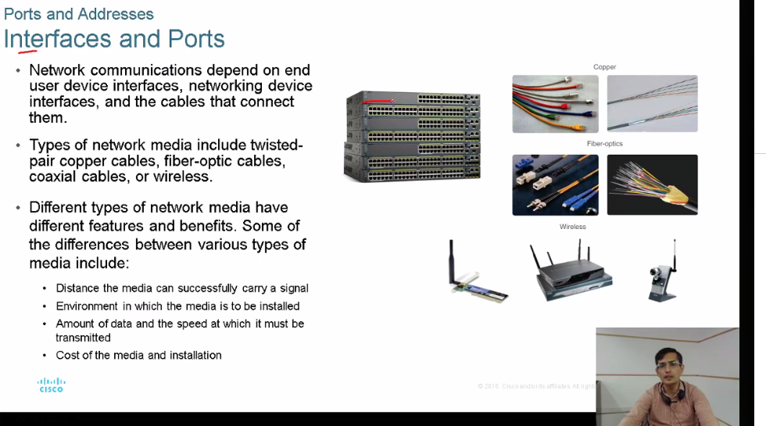

**Erase startup-config**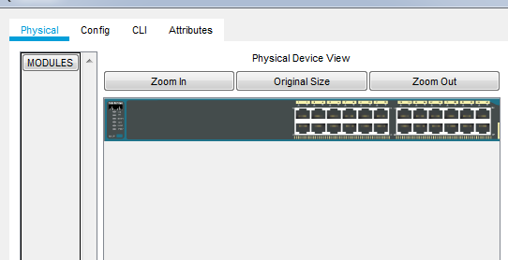

**Physical port**

To check no of port : Switch#show ip interface briKse bhi device ko coom k lye address chahye toh mac add h jo fix h then we have up addres

Subnetmask se yeh oata chlta h k humre ip address konse network ka h

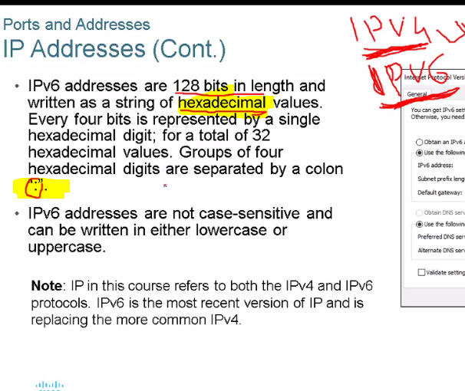

Har ek m 8 section hotey h separated by :

Har ek m 16 bit hoti h

Ek value 4 bit ko represrnt krrh h toh ek box m 4 valus hogi then : then after value

Aagr kse device ko n/w se connect krna hota h toh we connect thorugh sime port like ek wire wagera ko cable k

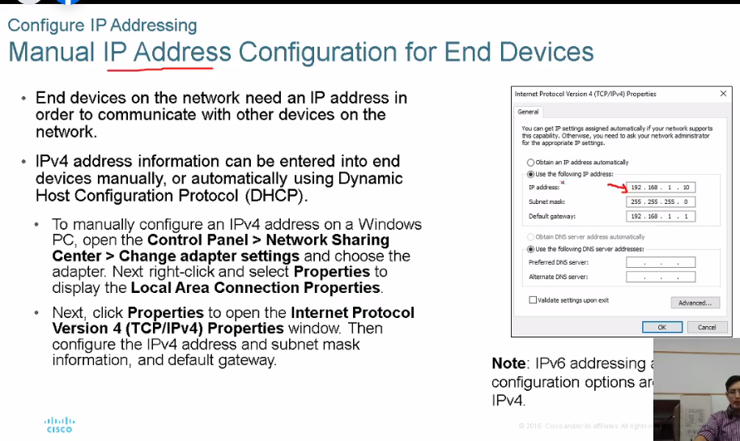

Ghr k andar route rh toh us m yeh server chlrha hota h is k pass e pool hota h ip address ka use pool se sabko allow krdetaa h

2-maunaully ip address assign kre

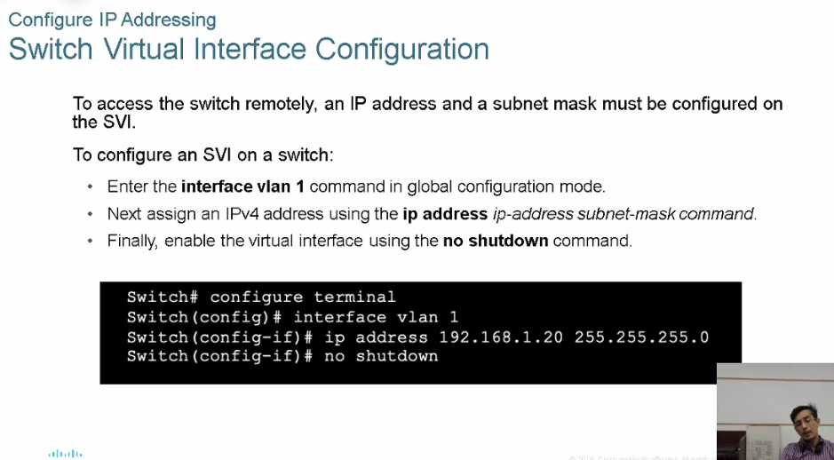

Agar device remote location pe ho or use config krna h toh we have to connect it us k lye hume uska ip address config krna aregaa

Switch ko ip address dene k lye we use SVI

Switch(config-if)#

Switch(config-if)#interface vlan 1

Switch(config-if)#ip address 192.168.1.20 255.255.255.0

Switch(config-if)#no shutdown

2 types of switches

1-managable :jis m ios chlrha hota h jiski confg hoti h like cisco

2-unmanagable::no need to configure.

Telenet:

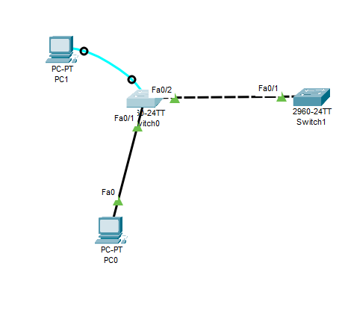

Switch(config)#hostname HR

HR(config)#enable password cisco

VTY:virtual switch

HR(config)#line vty 0 4

HR(config-line)#password ccna

HR(config-line)#login

HR(config-line)#exit

show ip interface bri

yeh up arhaa h qk yeh connect h sirf f0/1

HR(config)#interface vlan1

HR(config-if)#ip address 192.168.1.100 255.255.255.0

HR(config-if)#no shutdown

Bas yahi km dosre switch pe kare now PC ko config krna h

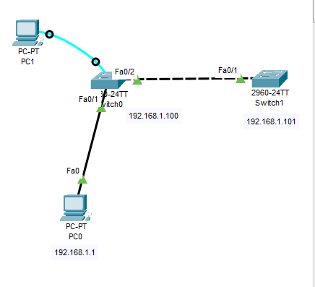

Now to check connectivity ping to these switches

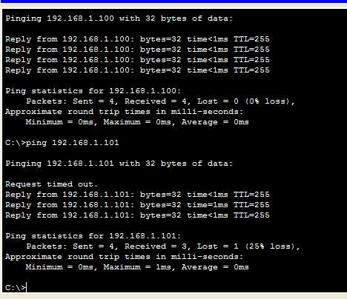

C:\>telnet 192.168.1.100

Trying 192.168.1.100 ...Open

User Access Verification

Password:

Password manrga h jo humne lagaay tha ab wo switch ko acces krparhe h

Agar humne sniffer laga dia toh sara ka sara data hacker k pass jarha h telnet ka

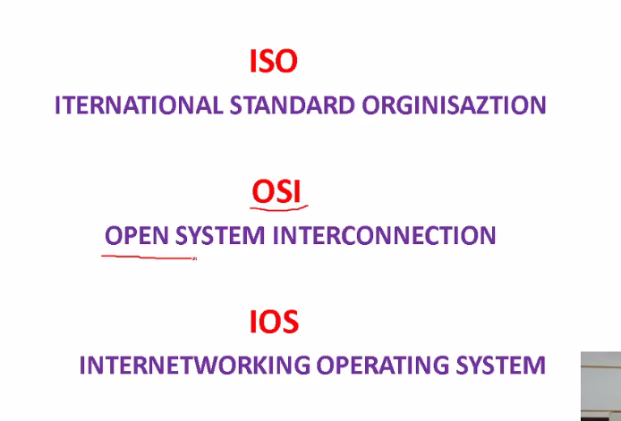

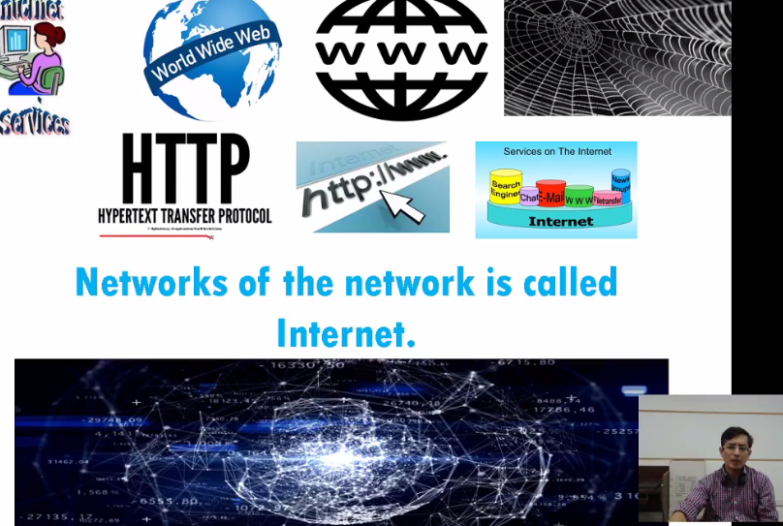

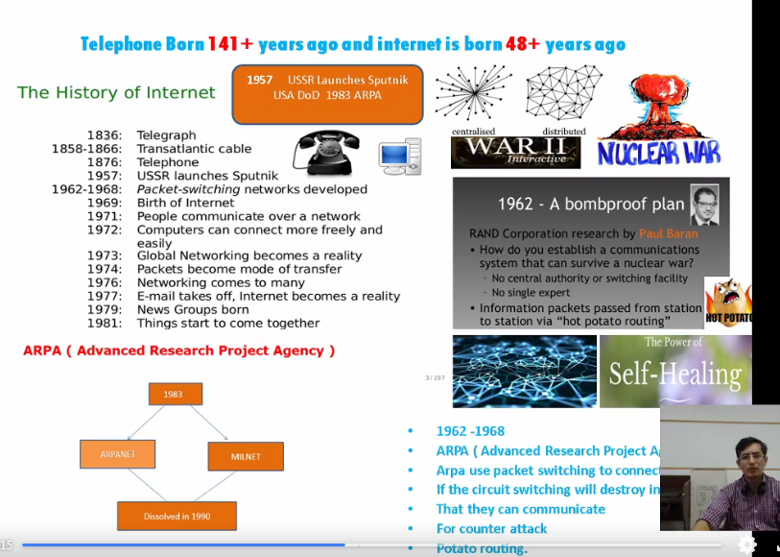

Self healing:like u=in human body ..agar koi n/w m issue ho toh khdu hi heal ho par masla tha b/c sab vendor dependent thy .

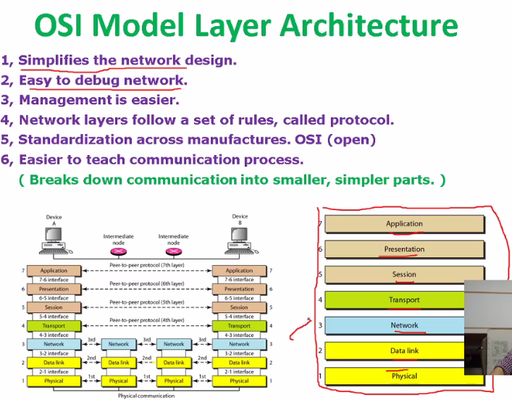

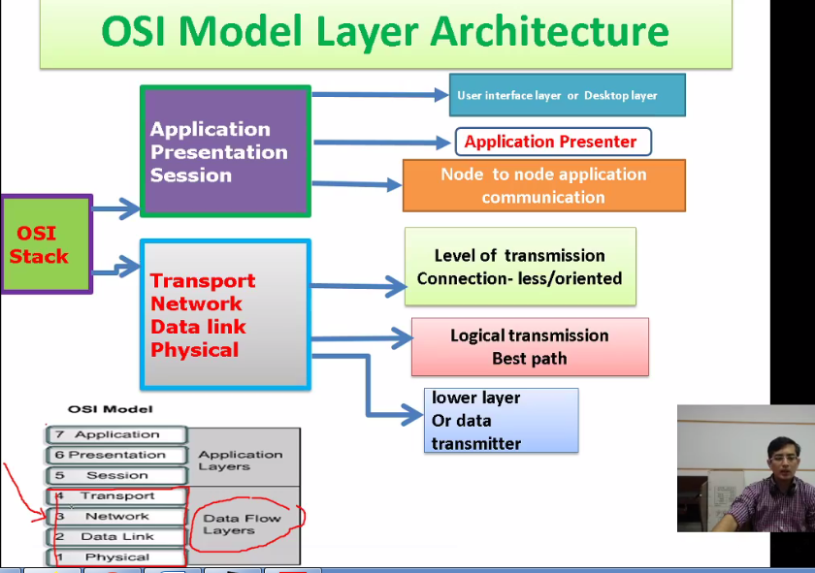

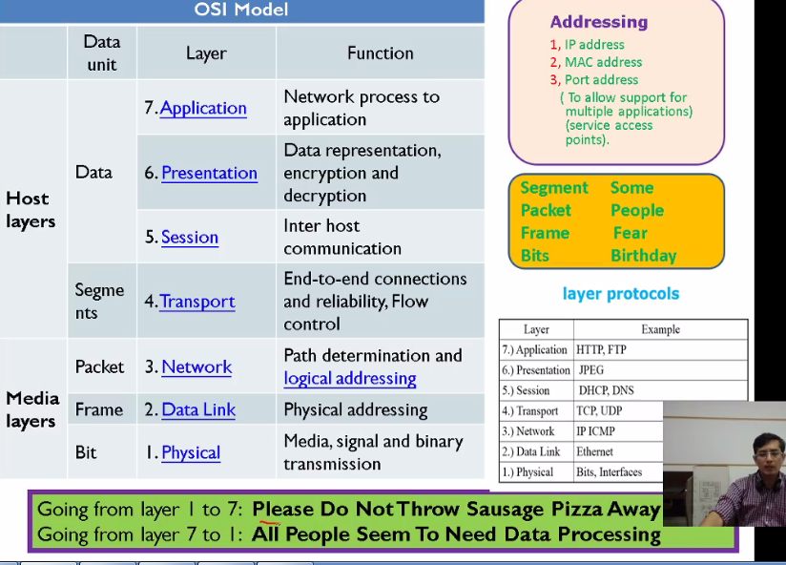

Application :www.google.com works on application

PDU: Applicatio presentation session

Segments :transport

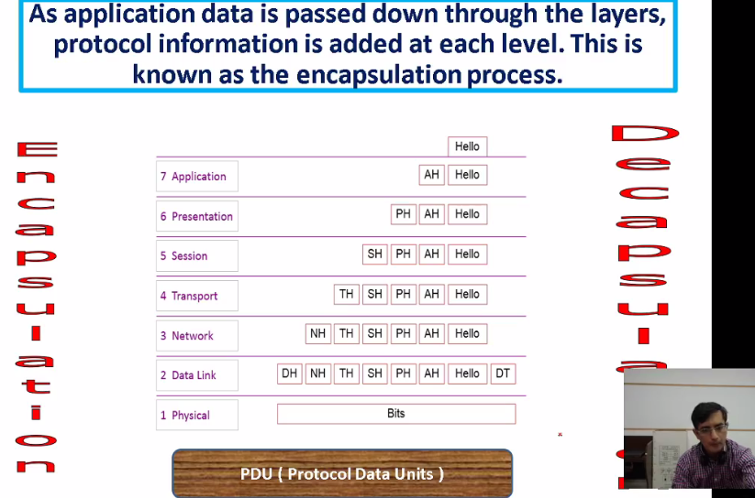

Dalatlink DH header or tailor lag rhe h tailor wager a checksum wagera bhi hota h

Sare header add hotey jarhe h toh this process is caleed encapsulation

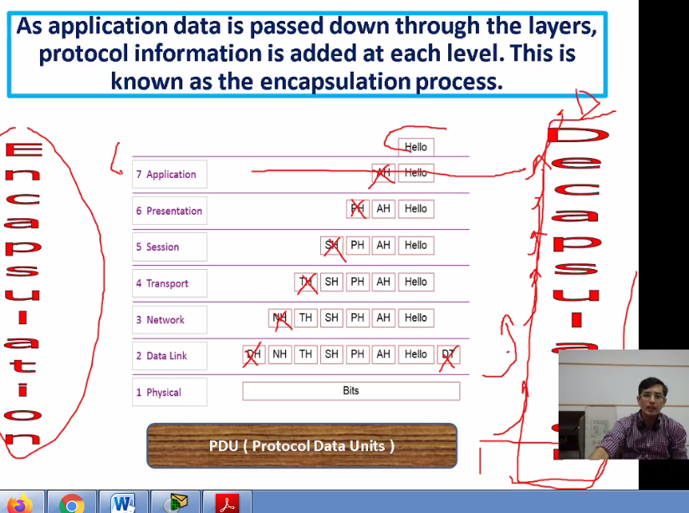

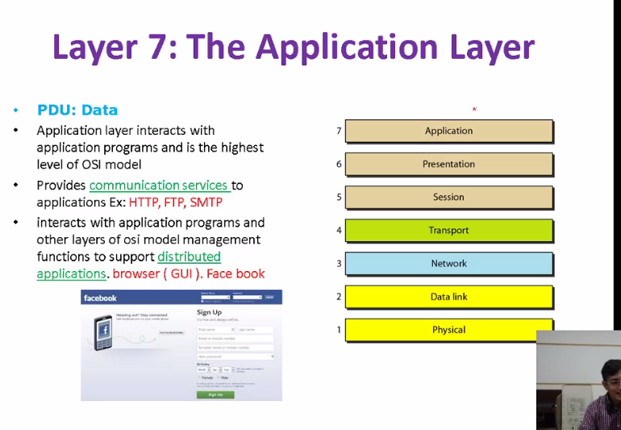

Application layer example is browser proctols pop http smtp wagera humre pass application e hotey h

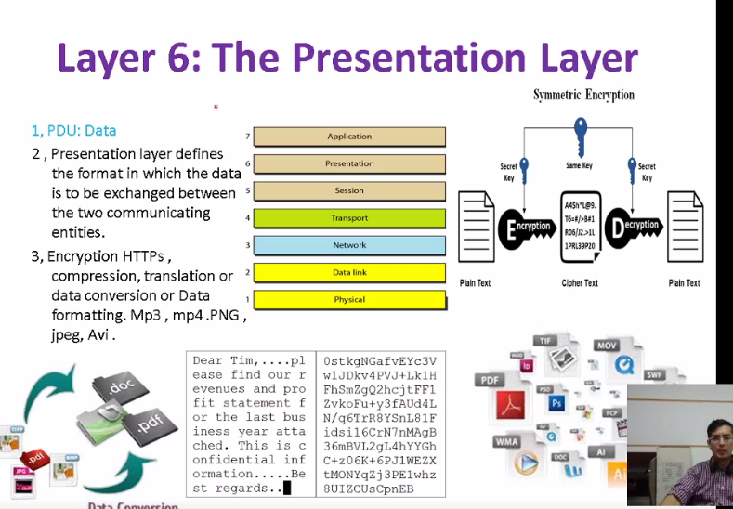

Presentation layer m formatting hoti h jis format m data jaye use formate m mile like apne mp3 send I h or wcievd horhe h text m

2-encryptuin hoti h data ko warpped kr detey h

http,telnet 🡪plain text

https🡪encrupted

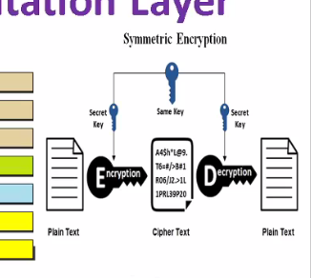

HELLO ----🡪 Ecruption (key h + 1)

IFMMP

Send kia h ecurption kr k reeving end k pass +1 ki kit hi usne isse decrypted krlia

Ise hum ciper text bhi boltey h

**Session Layer**

Kse data k beach m ek session create kia jata h like in real env hum inivatation detey wqt time location wagera detey h toh comp bhi session create krna parta h connection orented k lye

Session k beach m hi comm hoti h or bd m comm khtm hone k bd terminate hojati h

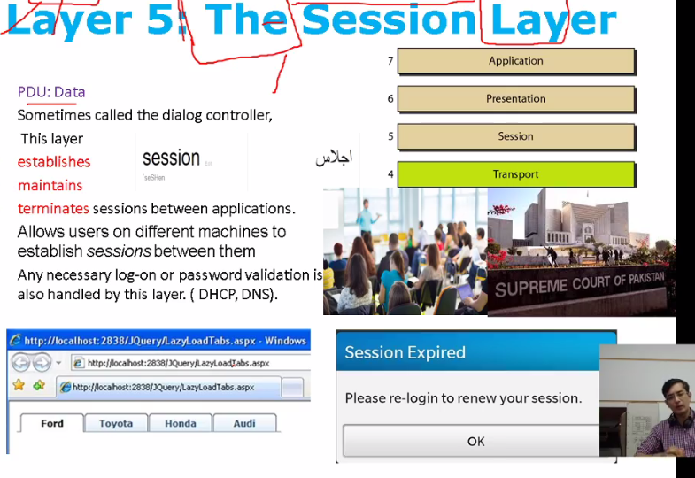

Iski bhi time limiet hota h

Transport Layer

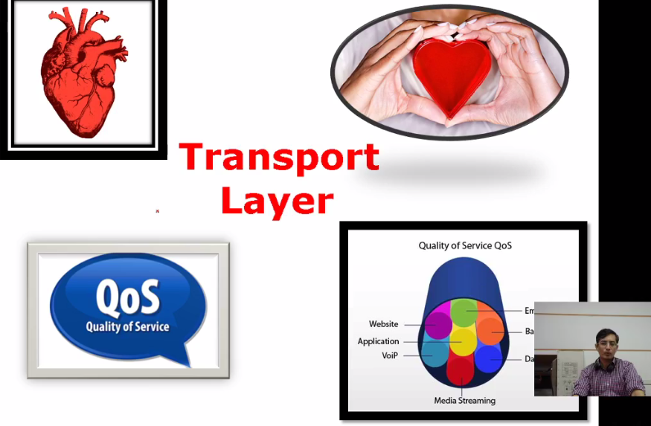

Heart of osi layer yahan data o segment kia jata h jse dat humre pass 80mb h

Par connection ki bandwidth 2 mp h toh hume 80 mb k data ko divide rkna parega 2 mb pe ..qk jab tk segment h kroga data send nh hota ..so according to the bandwisth data segment krtey h data ko chunks m divide krdetey h

10mb ko 2mp m convert krna h toh 5 packet banega are k segmen tko id bhi milegii

